BATTING BASE: START: SPIRITUAL BIRTH:
Knowing Christ; Infant Stage

MODULE 1: NEW LIFE LESSONS

LESSON 6: FELLOWSHIP

INTRODUCTION

REVIEW:

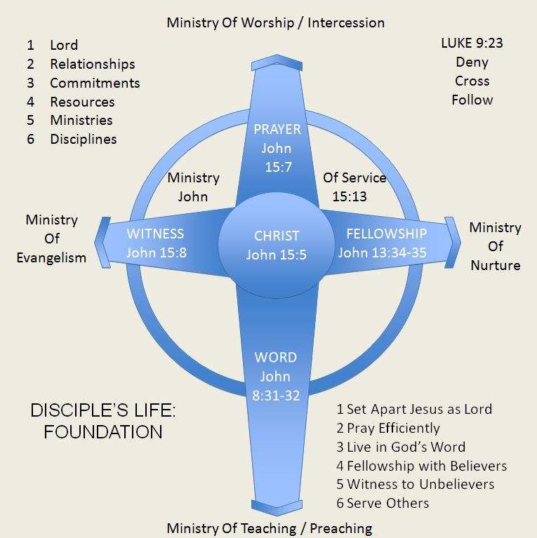

INTRO TO FELLOWSHIP

Luke 4:16
King James Version (KJV)

¹⁶ And he came to Nazareth, where he had been brought up: and, as his custom was, he went into the synagogue on the sabbath day, and stood up for to read.

I. _____________________

Hebrews 10:24-25
King James Version (KJV)

²⁴ And let us consider one another to provoke unto love and to good works:
²⁵ Not forsaking the assembling of ourselves together, as the manner of some is; but exhorting one another: and so much the more, as ye see the day approaching.

A. PROVOKE ____________________________

B. FORSAKE NOT ______________

II. ________________

A. THERE ARE MANY HOME CHURCHES

1. These are churches in different localities

Romans 16:16
King James Version (KJV)
¹⁶ Salute one another with an holy kiss. The churches of Christ salute you.

1 Thessalonians 2:14
King James Version (KJV)
¹⁴ For ye, brethren, became followers of the churches of God which in Judaea are in Christ Jesus: for ye also have suffered like things of your own countrymen, even as they have of the Jews:

2. These are many churches in one locality

Galatians 1:1-2
King James Version (KJV)

1 Paul, an apostle, (not of men, neither by man, but by Jesus Christ, and God the Father, who raised him from the dead;)
² And all the brethren which are with me, unto the churches of Galatia:

B. WE CHOSE OUR HOME CHURCH

III. ______________________

Ephesians 5:23-25
King James Version (KJV)

²³ For the husband is the head of the wife, even as Christ is the head of the church: and he is the saviour of the body.
²⁴ Therefore as the church is subject unto Christ, so let the wives be to their own husbands in every thing.
²⁵ Husbands, love your wives, even as Christ also loved the church, and gave himself for it;

IV. _____________________

A. CELEBRATION

Ephesians 5:19
New International Version (NIV)

¹⁹ speaking to one another with psalms, hymns, and songs from the Spirit. Sing and make music from your heart to the Lord, ²⁰ always giving thanks to God the Father for everything, in the name of our Lord Jesus Christ.

B. RESTORATION

Galatians 6:1-2
King James Version (KJV)

6 Brethren, if a man be overtaken in a fault, ye which are spiritual, restore such an one in the spirit of meekness; considering thyself, lest thou also be tempted.
² Bear ye one another's burdens, and so fulfil the law of Christ.

C. INSPIRATION

Hebrews 10:24-25
King James Version (KJV)
²⁴ And let us consider one another to provoke unto love and to good works:
²⁵ Not forsaking the assembling of ourselves together, as the manner of some is; but exhorting one another: and so much the more, as ye see the day approaching.

B. PREPARATION

Ephesians 4:11-12
King James Version (KJV)
¹¹ And he gave some, apostles; and some, prophets; and some, evangelists; and some, pastors and teachers;
¹² For the perfecting of the saints, for the work of the ministry, for the edifying of the body of Christ:

V. _____________________

A. COMMITMENT

1. Loyalty

Romans 12:10
New International Version (NIV)
¹⁰ Be devoted to one another in love.Honor one another above yourselves.

2. Permanence

a. Body

Ephesians 4:1-13; 1 Corinthians 12

b. Building

Ephesians 2:19-22

c. Family

Ephesians 3:14-15

d. Flock

Acts 20:28

3. Responsibility

Romans 12:6-8
King James Version (KJV)

⁶ Having then gifts differing according to the grace that is given to us, whether prophecy, let us prophesy according to the proportion of faith;
⁷ Or ministry, let us wait on our ministering: or he that teacheth, on teaching;
⁸ Or he that exhorteth, on exhortation: he that giveth, let him do it with simplicity; he that ruleth, with diligence; he that sheweth mercy, with cheerfulness.

B. UNITY

Ephesians 4:1-6
King James Version (KJV)

4 I therefore, the prisoner of the Lord, beseech you that ye walk worthy of the vocation wherewith ye are called,
² With all lowliness and meekness, with longsuffering, forbearing one another in love;
³ Endeavouring to keep the unity of the Spirit in the bond of peace.
⁴ There is one body, and one Spirit, even as ye are called in one hope of your calling;
⁵ One Lord, one faith, one baptism,
⁶ One God and Father of all, who is above all, and through all, and in you all.

1. Doctrine

2. Interests

Colossians 3:1-2
King James Version (KJV)
3 If ye then be risen with Christ, seek those things which are above, where Christ sitteth on the right hand of God.
² Set your affection on things above, not on things on the earth.

3. Vision

Matthew 6:10
King James Version (KJV)
¹⁰ Thy kingdom come, Thy will be done in earth, as it is in heaven.

Ephesians 4:11-13
King James Version (KJV)
¹¹ And he gave some, apostles; and some, prophets; and some, evangelists; and some, pastors and teachers;
¹² For the perfecting of the saints, for the work of the ministry, for the edifying of the body of Christ:
¹³ Till we all come in the unity of the faith, and of the knowledge of the Son of God, unto a perfect man, unto the measure of the stature of the fulness of Christ:

4. Mission

Matthew 28:18-20
King James Version (KJV)
¹⁸ And Jesus came and spake unto them, saying, All power is given unto me in heaven and in earth.
¹⁹ Go ye therefore, and teach all nations, baptizing them in the name of the Father, and of the Son, and of the Holy Ghost:
²⁰ Teaching them to observe all things whatsoever I have commanded you: and, lo, I am with you always, even unto the end of the world. Amen.

VI. _____________________

A. DIET

2 Corinthians 6:14-18
King James Version (KJV)
¹⁴ Be ye not unequally yoked together with unbelievers: for what fellowship hath righteousness with unrighteousness? and what communion hath light with darkness?
¹⁵ And what concord hath Christ with Belial? or what part hath he that believeth with an infidel?
¹⁶ And what agreement hath the temple of God with idols? for ye are the temple of the living God; as God hath said, I will dwell in them, and walk in them; and I will be their God, and they shall be my people.
¹⁷ Wherefore come out from among them, and be ye separate, saith the Lord, and touch not the unclean thing; and I will receive you.
¹⁸ And will be a Father unto you, and ye shall be my sons and daughters, saith the Lord Almighty.

1 Corinthians 15:33
King James Version (KJV)
³³ Be not deceived: evil communications corrupt good manners.

B. EXERCISE

Hebrews 10:24-25
King James Version (KJV)
²⁴ And let us consider one another to provoke unto love and to good works:
²⁵ Not forsaking the assembling of ourselves together, as the manner of some is; but exhorting one another: and so much the more, as ye see the day approaching.

John 13:34-35
King James Version (KJV)
³⁴ A new commandment I give unto you, That ye love one another; as I have loved you, that ye also love one another.
³⁵ By this shall all men know that ye are my disciples, if ye have love one to another.

CONCLUSION

1. Make sure you’re a part of the universal church

2. Choose a local church you can call your home church to commit and attend faithfully

3. Be a part of a discipleship group

4. Serve regularly

5. Support it: including giving

6. Meet with fellow believers even outside of congregational gatherings

MEMORY VERSES:

Hebrews 10:24-25
King James Version (KJV)
²⁴ And let us consider one another to provoke unto love and to good works:
²⁵ Not forsaking the assembling of ourselves together, as the manner of some is; but exhorting one another: and so much the more, as ye see the day approaching.

John 13:34-35
King James Version (KJV)
³⁴ A new commandment I give unto you, That ye love one another; as I have loved you, that ye also love one another.
³⁵ By this shall all men know that ye are my disciples, if ye have love one to another.

